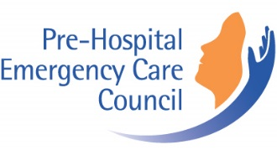
Request for Access to Records under the
Freedom of Information Act, 2014

Please save the form to your PC and type directly on the form
Details of Applicant:
Surname:
First name:
Tel number home:
Tel number mobile:
Email:
Postal Address:

Personal Information
Before you are given access to personal information relating to yourself, you may be asked to provide proof of your identity.

Form of Access
My preferred form of access is: (please tick as appropriate)

By Post | ☐
Other – please specify:

Details of Request
In accordance with Section 12 of the FOI Act, I request access to records which are:
(Please tick as appropriate)

Personal | ☐
Non-personal | ☐
In the space provided please describe the records as fully as you can. If you are requesting personal information, please state precisely in whose name those records are held. You will not normally be given access to personal information of another person unless you have obtained the written consent of that person.

I request the following records:

Applicant signature:

(print the form to sign and return by post or alternatively scan and email)
Date: Click here to enter a date.

Submit to: FOI Officer, Pre-Hospital Emergency Care Council, Abbey Moat House, Abbey Street, Naas, Co. Kildare.
Or scan and email to: foi@phecc.ie

For office use only
Date FOI request received:
Identity verified:
Consent confirmed:

